KE51 - KE51 - Create Profit Center

Functionality
A profit center is a management-oriented organizational unit used for internal controlling purposes. Dividing your company up into profit centers allows you to analyze areas of responsibility and to delegate responsibility to decentralized units, thus treating them as "companies within the company".
Create and Maintain Profit Center Master data.

Scenario
Create Profit Center 2204 (EDC), and setup the relevant data (i.e. Long text of the Profit Center name, Responsible Person, Profit Center Group, Company codes allowed to post to it)

Menu Path | Accounting → Controlling → Profit Center Accounting → Master Data → Profit Center → Individual Processing → KE51 - Create
Transaction Code | KE51

1. Double Click on KE51 – Create.

Set Controlling Area

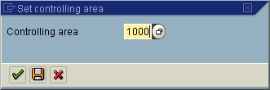

2. Update the following fields:

Field Name | Field Description | Values
Controlling Area | Organizational controlling area element | Example: 1000

Note: This screen will only appear if you have not previously set a default Controlling area. To do this, refer to user default settings. Menu: System > User Profile > Own data.

3. Click Enter .

Create Profit Center

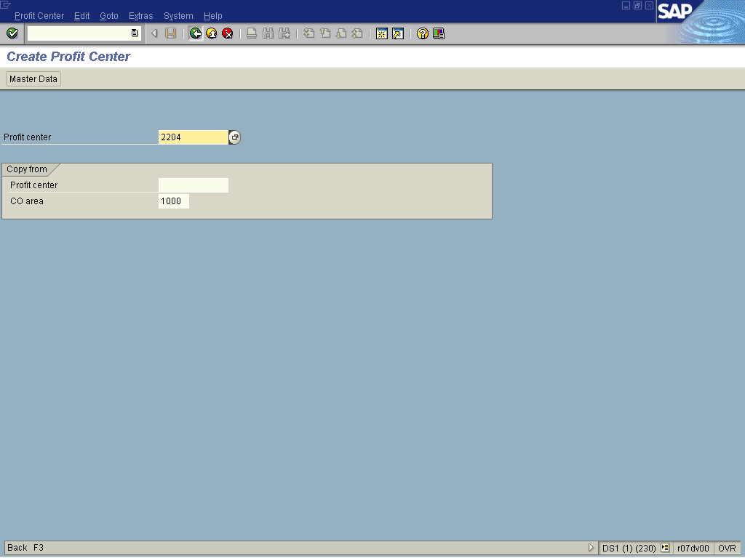

4. Update the following fields:

Field Name | Field Description | Values
Profit Center | Number of the Profit Center. | Example: 2204

5. Click Enter .
Create Profit Center

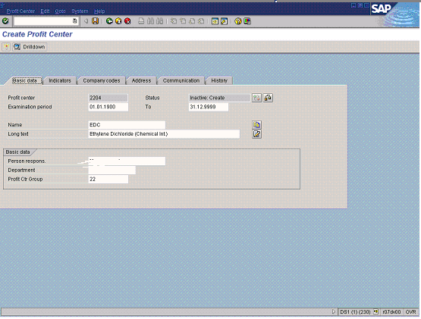

6. Update the following required and optional fields:

Field Name | Description | Values
Name | Description of the Profit Center. | Example: EDC
Long text | Contains an explanatory text on the line item. | Example: Ethylene Dichloride (Chemical Int.)
Person respons. | Name of the person in charge of the profit center. | Example: XYZ
Profit Ctr Group | Is a grouping of profit centers in the Standard Hierarchy. | Example: 22. Click on the button for more options

7. Click <tab button> Indicators .

Create Profit Center

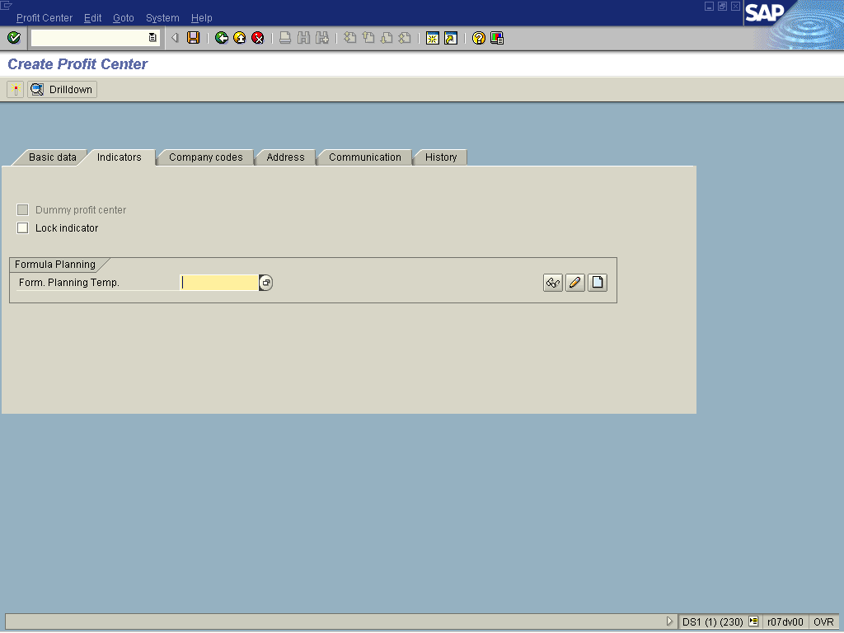

Note: This screen is used to lock profit centers and create dummy profit centers.
8. Click <tab button> Company codes .

Create Profit Center

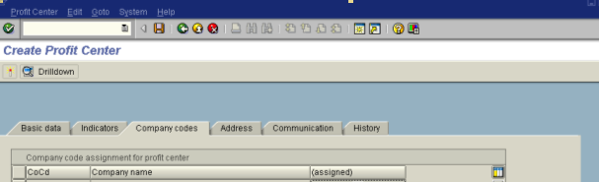

Note: Indicates whether or not a company code is assigned to a profit center. If an assignment exists, the profit center can be posted to within the company code. Otherwise, it is locked for postings within the company code.

9. Click <tab button> Address .

Create Profit Center

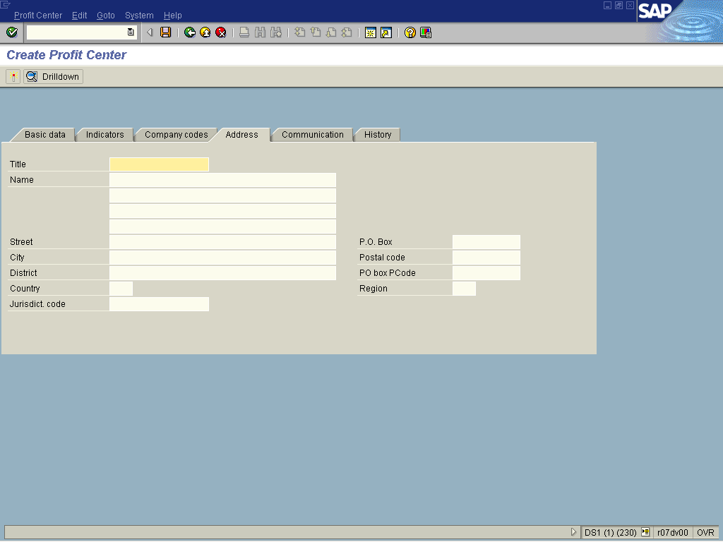

Note: Enter any relevant profit center address details.

10. Click <tab button> Communication .

Create Profit Center

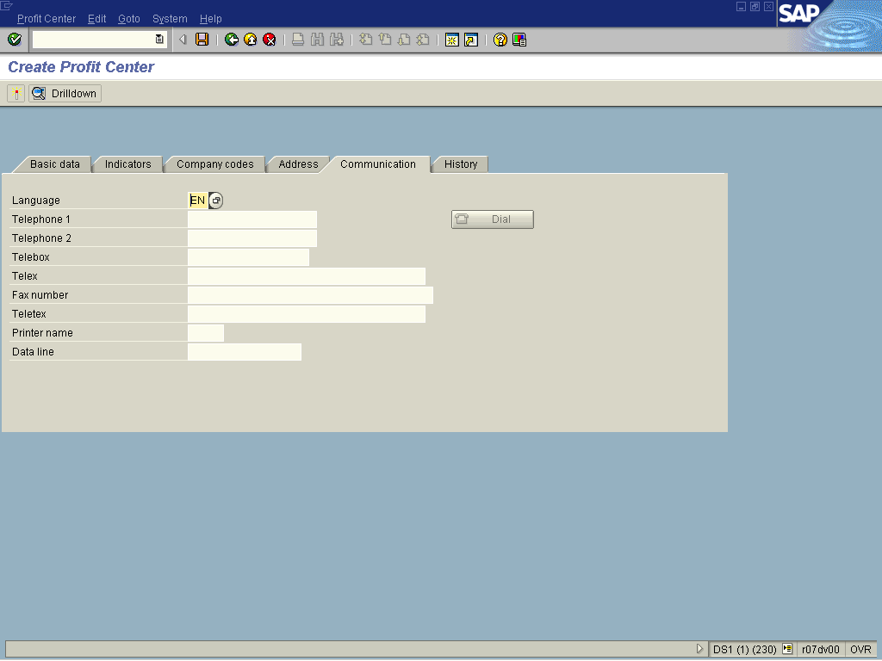

Note: This screen contains any relevant communication details of the profit center. These fields are not required and can be left blank.

11. Click <tab button> History

Create Profit Center

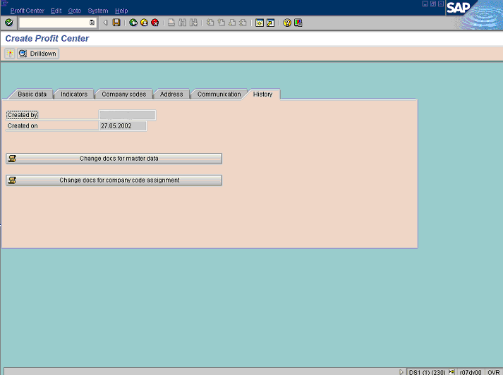
 To see a history of change documents for the profit center, click on the button.
12. Click <tab button> Basic data .

Create Profit Center

13. Click Save to save the changes made.
Information
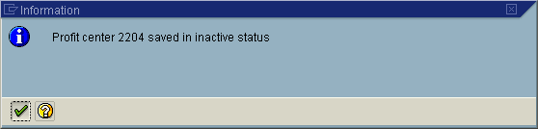
14. Click Enter .
15. Click Activate Button to allow posting to the Profit Center.

